CLASS TEST F.M.- 15

Chapter: Adolescence – A Stage of Growth and Change
Q1. During adolescence, a student experiences a sudden increase in height, changes in body proportions and development of reproductive organs. Which statement best explains why these changes occur together?
A. The body stops producing growth-related hormones temporarily.
B. Hormonal changes coordinate several physical and reproductive changes.
C. Only the reproductive organs grow during adolescence.
D. These changes occur only because of increased food intake.
Q2. Riyansh notices that his voice is becoming deeper and that hair is appearing in new regions of his body. His friend says that these changes indicate illness. Which response is scientifically most appropriate?
A. These are generally normal changes associated with puberty.
B. Such changes occur only because of poor personal hygiene.
C. These changes indicate that the body has stopped growing.
D. Such changes occur only in adults.
Q3. Two students of the same age show different rates of height increase. One student concludes that the shorter student has a health problem. Which conclusion is scientifically justified?
A. Height must increase at exactly the same rate in all adolescents.
B. Growth always stops after the onset of puberty.
C. Only nutrition determines the final height of a person.
D. Growth patterns can vary among individuals because of several factors.
Q4.Rohan suddenly hears a loud explosion. His heartbeat becomes faster. Which hormone causes this response?
A. Insulin B. Adrenaline C. Thyroxine D. Growth hormone
Q5. A person's thyroid gland produces insufficient thyroxine. Which body process is most likely to be affected?
A. Metabolism B. Hearing
C. Blood clotting D. Digestion of food in the stomach only
CASE STUDY: (5)
Ananya, aged 13, gets her first menstrual period. She learns that approximately once every month, an egg is released from an ovary. During this time, the lining of the uterus becomes thick and rich in blood vessels to prepare for a possible pregnancy. If fertilisation does not occur, the egg and the thickened uterine lining are shed from the body as menstrual flow.
Q6. What is the process described in the case study called as?
Q7. What happens if the released egg is not fertilised?
Q8. A student says, "Menstruation is an illness and girls should not participate in normal activities during it." Is this statement correct? Explain.
Q9. Which hormone is mainly associated with female reproductive functions?
Q10. What is the first menstrual period called as?
Q11. A girl is currently 148 cm tall at age 11. Girls at 11 reach 88% of adult height. Calculate her adult height. (2)
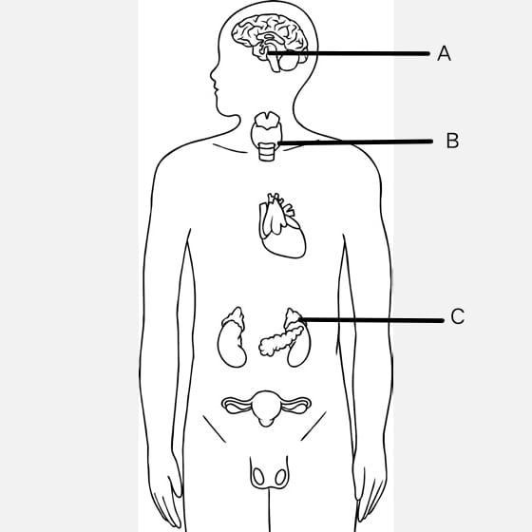
Q12. Identify the endocrine glands and name the hormones produced by them. (3)

